Name: Moses Muamba-Nzambi
Course: CST-250
Assignment: Activity 2
Date: Feb 15, 2026
Instructor: Mohammad Abu Matar

Activity 2

Github Link:
https://github.com/MosesMNZ/CST-250-Activity2

Part 1.

After Running the xUnit tests for these GetIventory and GetShoppingCart methods, the project worked as below:
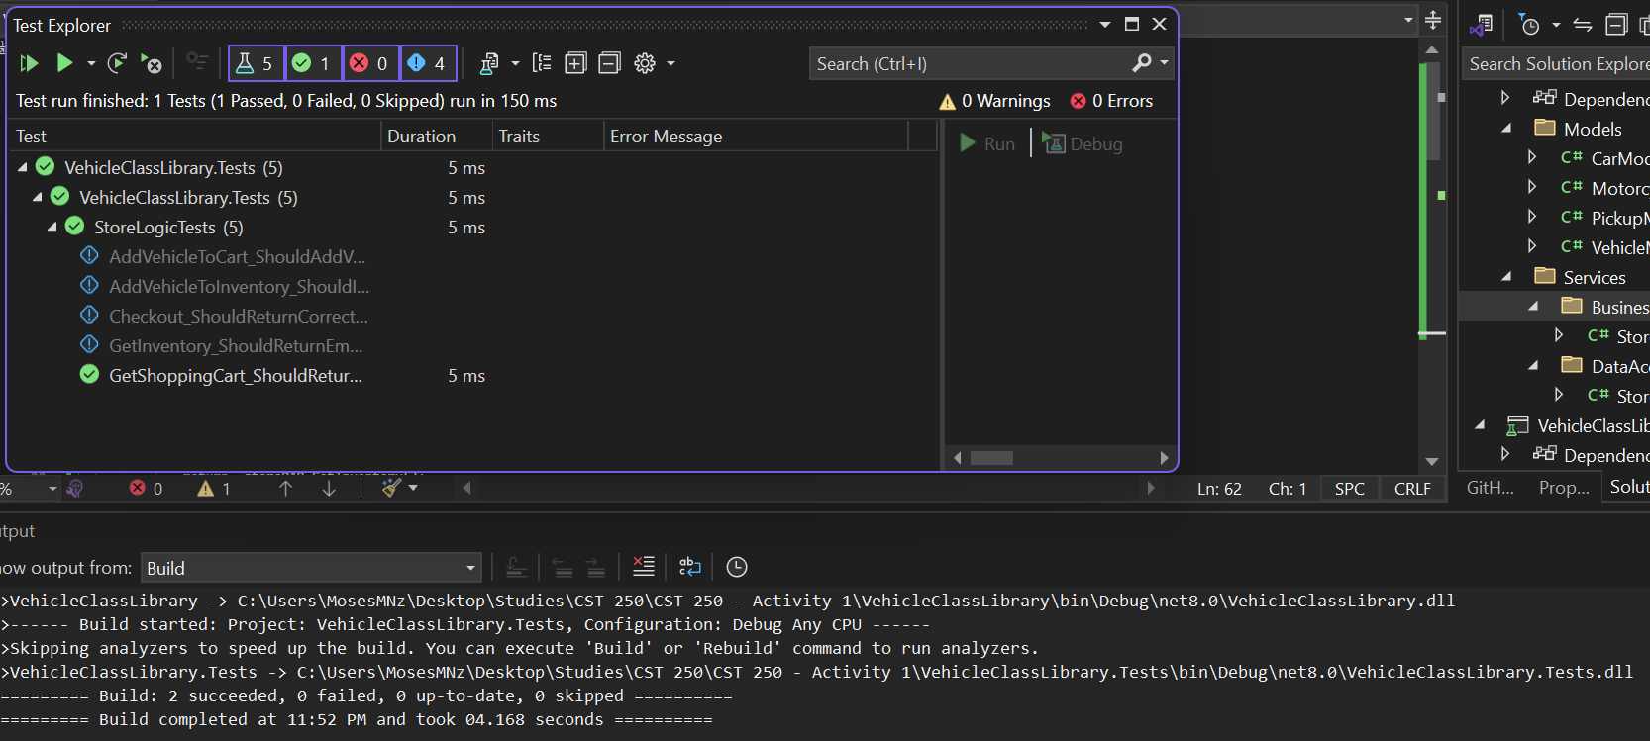

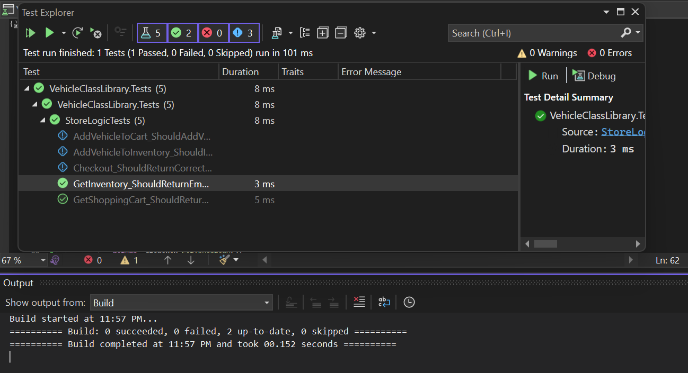

After Running the xUnit tests for the AddVehicleToIventory method, the project worked as below:
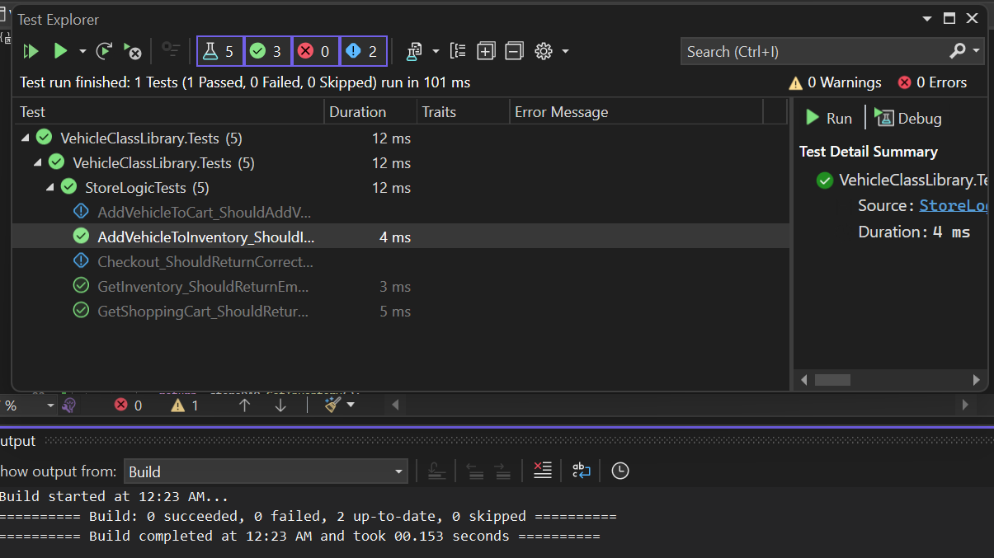

After Running the xUnit tests for the AddVehicleToCart method, the project worked as below:
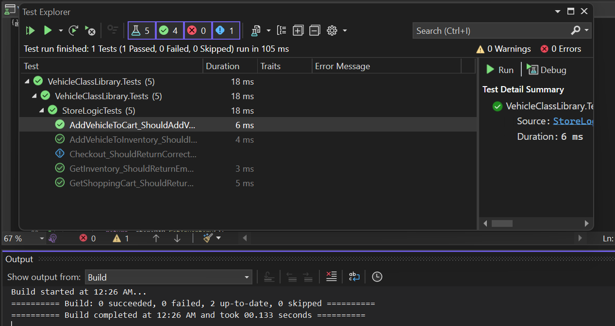

After Running the xUnit tests for the Checkout method, the project worked as below:

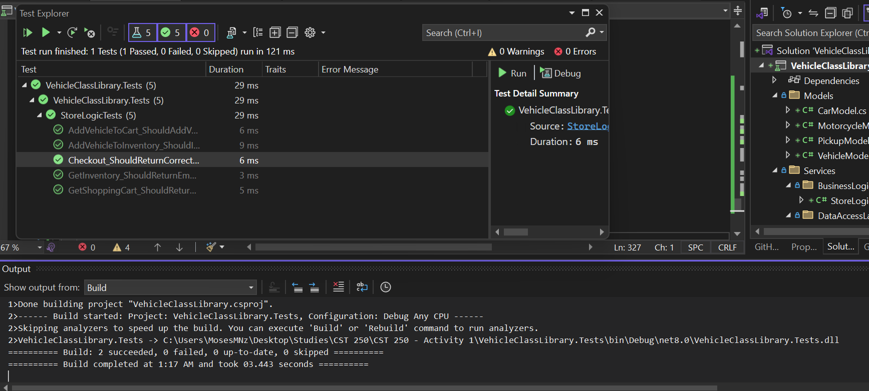

Note: Part 2 is on the next page.

Part 2.

- Take a creenshot of the citations for VehicleModel, CarModel, MotorcycleModel, PickupModel, StoreDAO, and StoreLogic. Make sure to include the class declarations in the images.
- Take a screenshotscreenshot of the VehicleModel, CarModel, MotorcycleModel, PickupModel, StoreDAO, and StoreLogic constructors (default and parameterized).
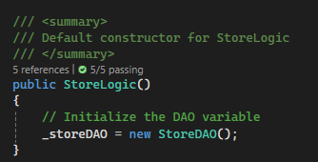

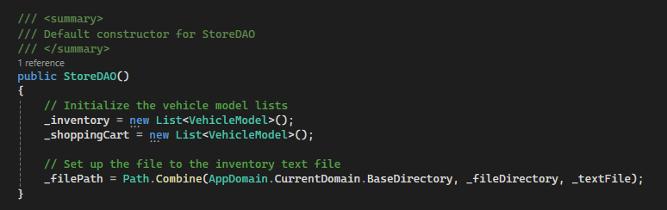

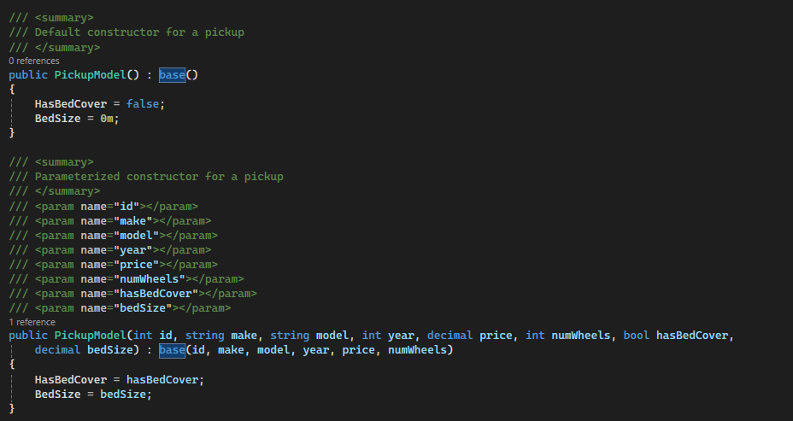

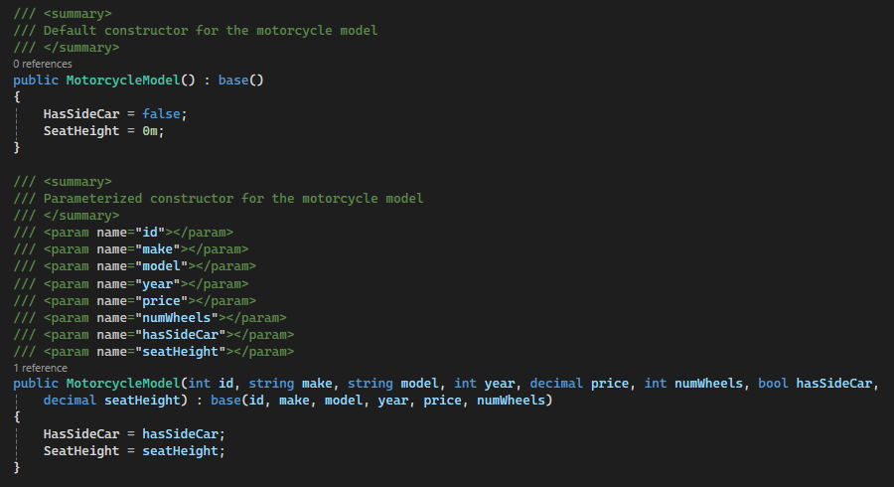

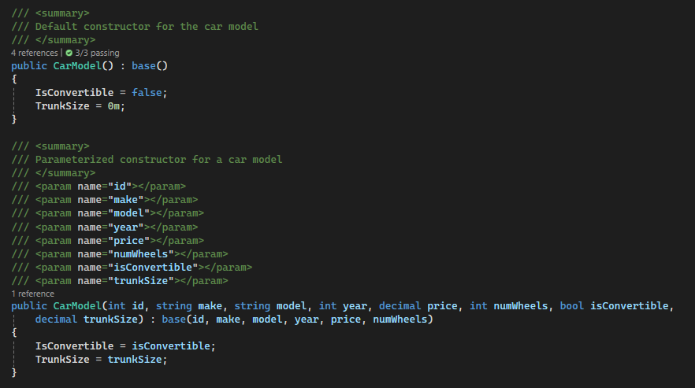

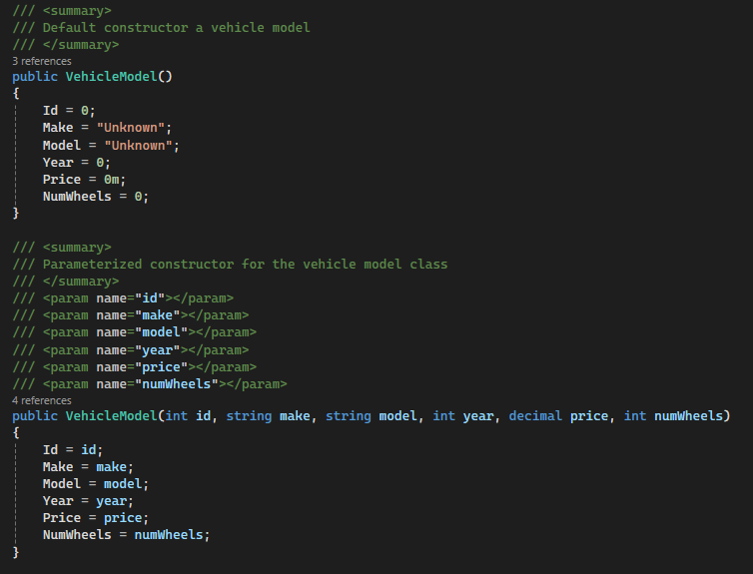

- Take a screenshotscreenshot of the VehicleModel, CarModel, MotorcycleModel, and PickupModel ToString methods.
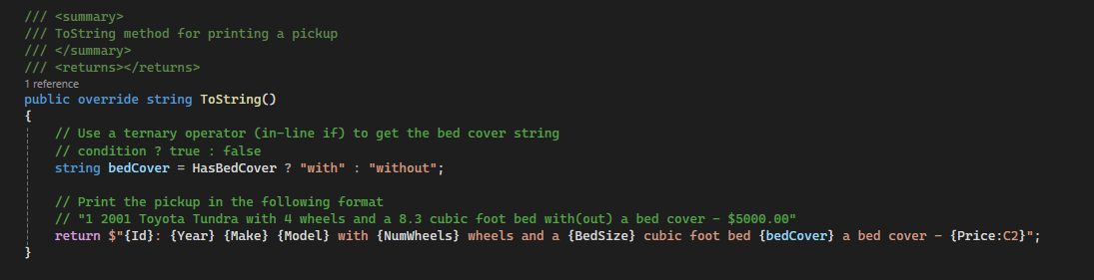

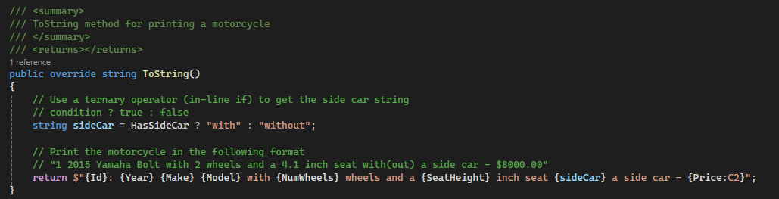

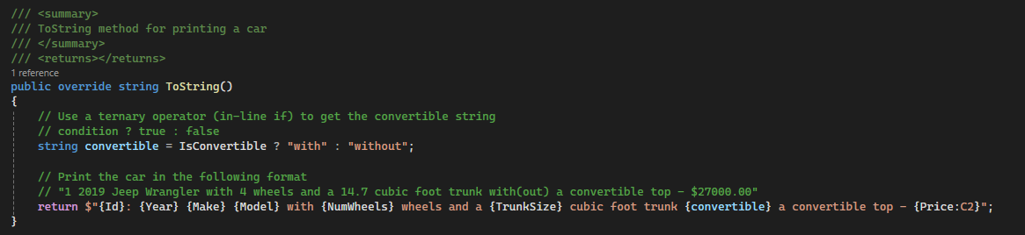

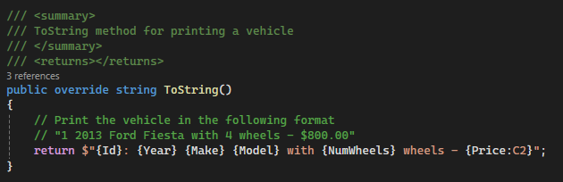

- Take a screenshotscreenshot of the GetInventory, GetShoppingCart, AddVehicleToInventory, AddVehicleToCart, WriteInventory, ReadInventory, ParseInteger, ParseDecimal, ParseBoolean, and Checkout methods in StoreDAO.

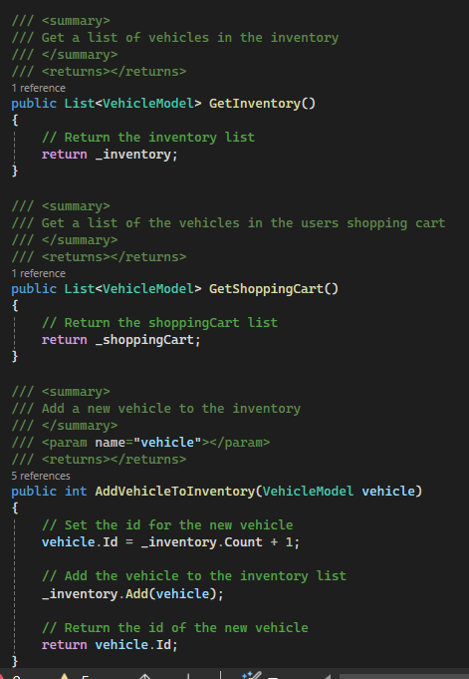

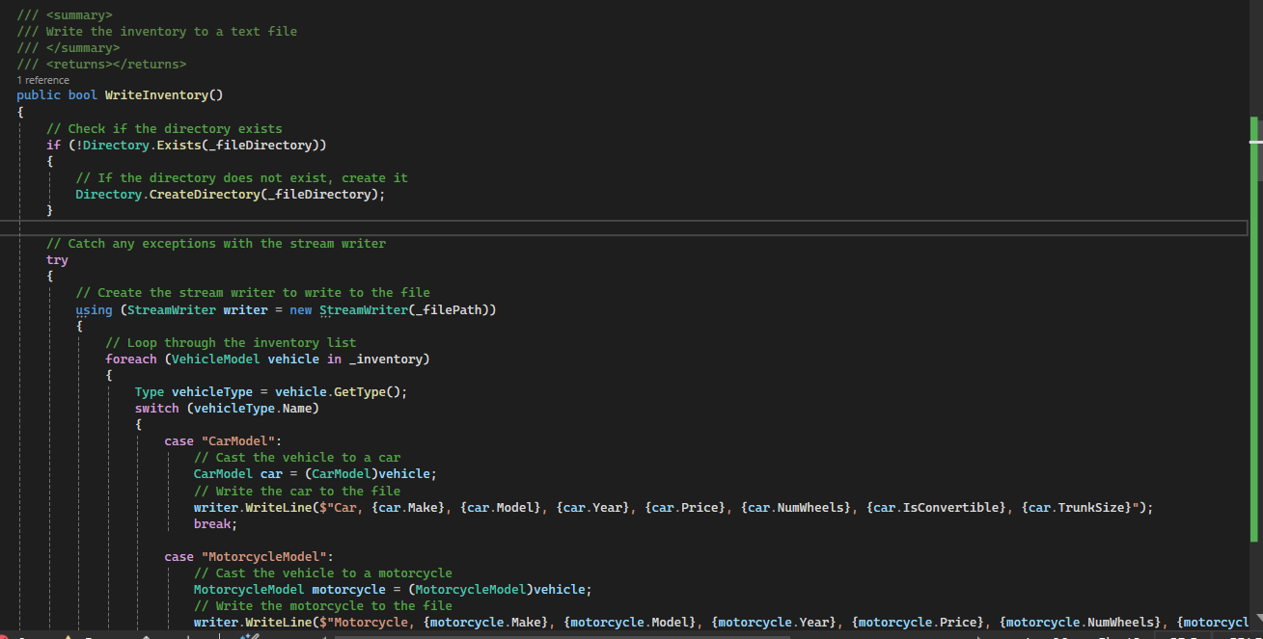

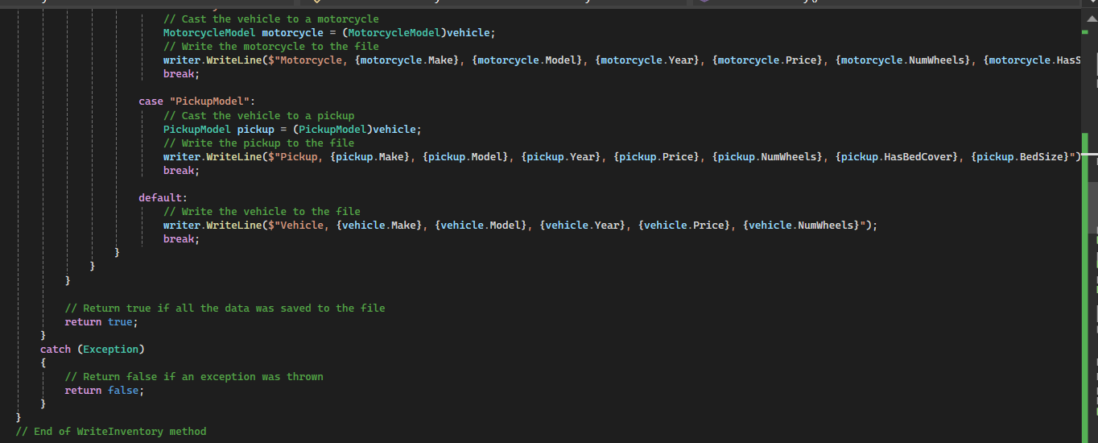

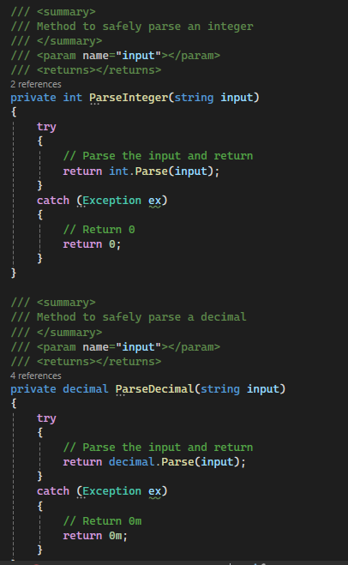

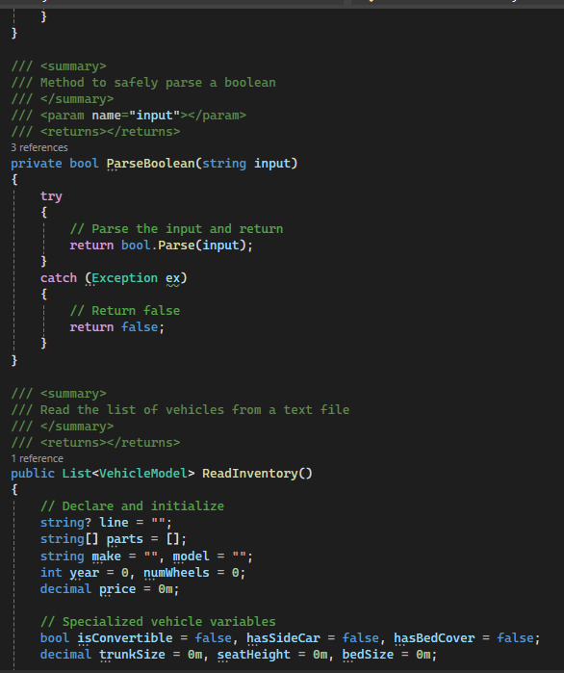

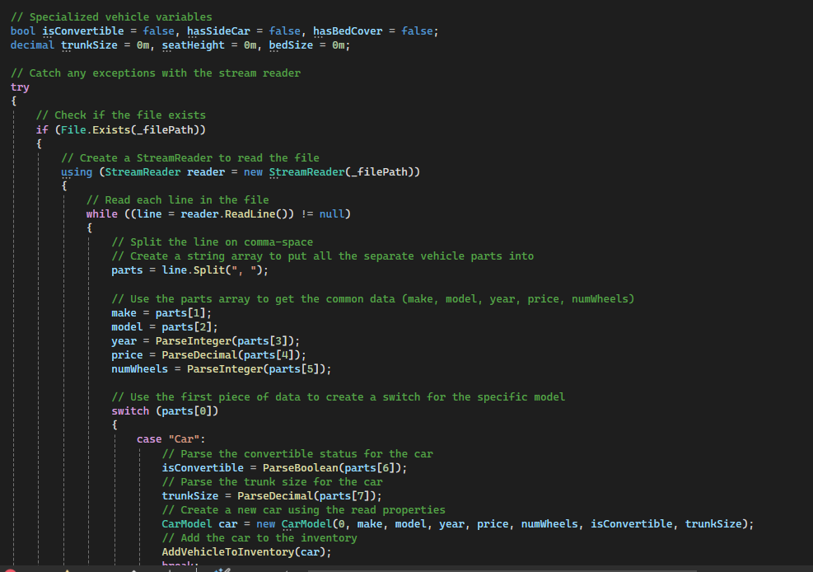

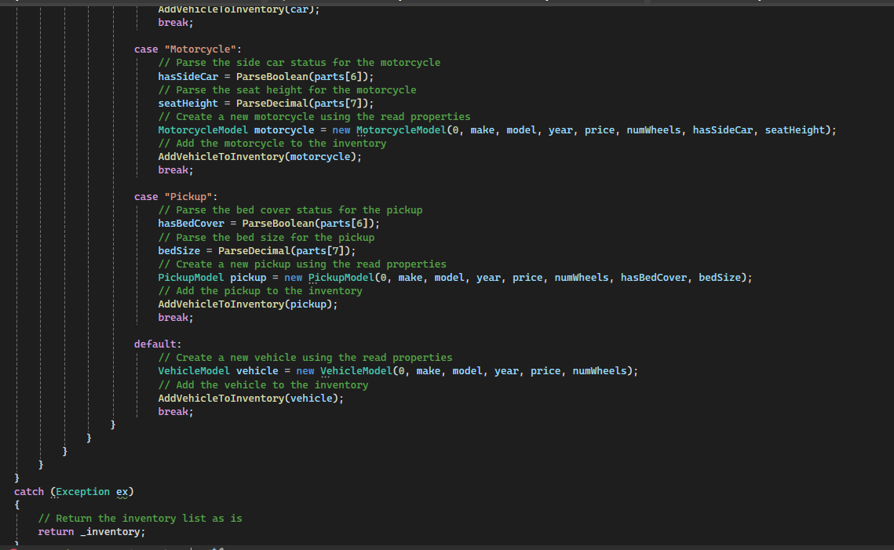

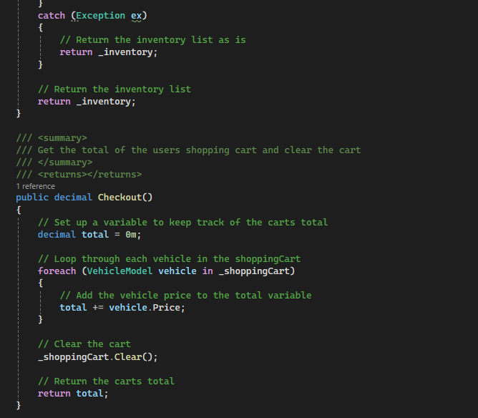

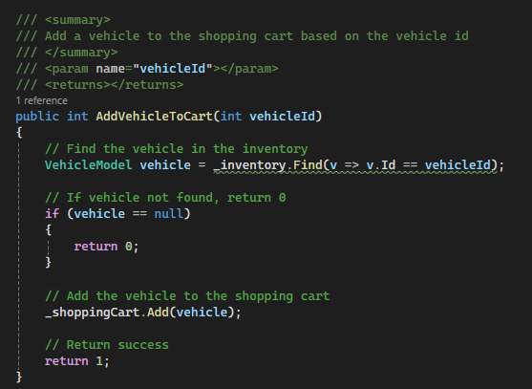
- Take a screenshotscreenshot of the GetInventory, GetShoppingCart, AddVehicleToInventory, AddVehicleToCart, WriteInventory, ReadInventory, and Checkout methods in StoreLogic.

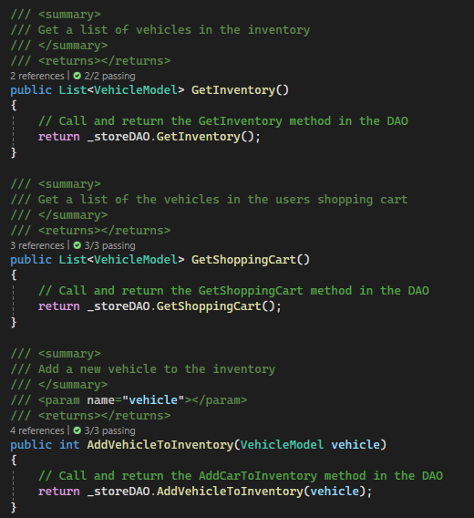

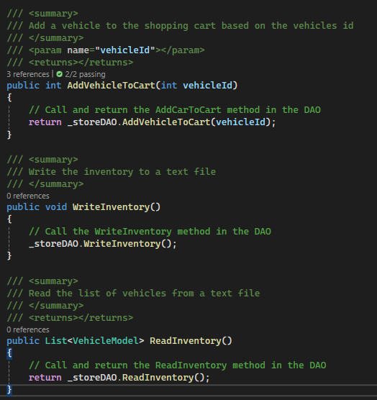

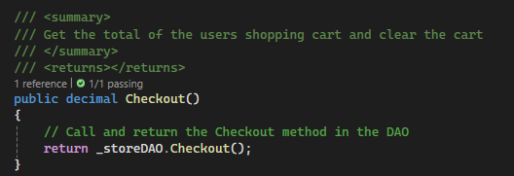

Screenshots of new methods
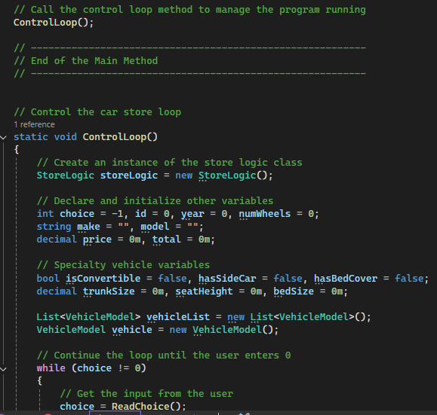
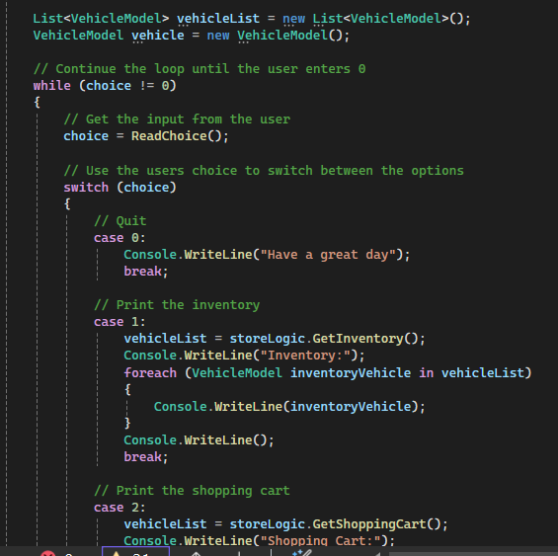
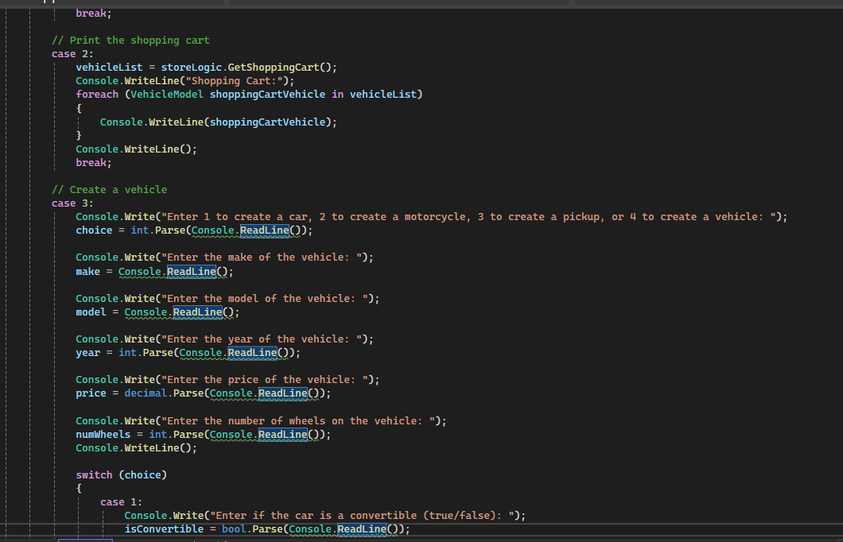
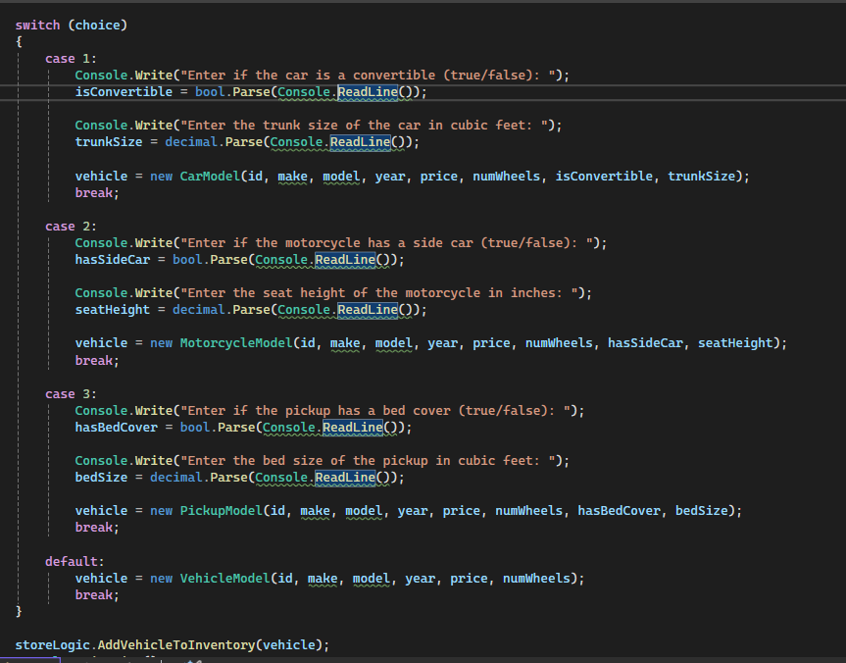

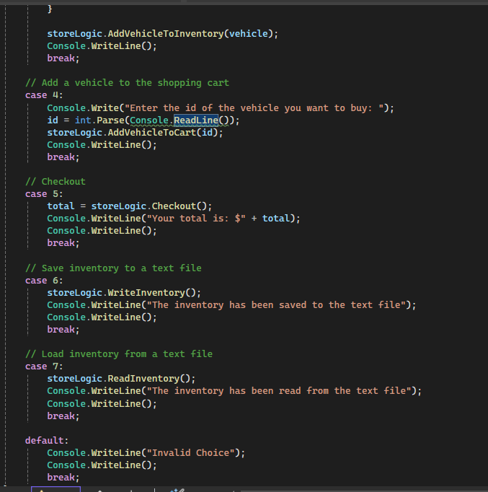
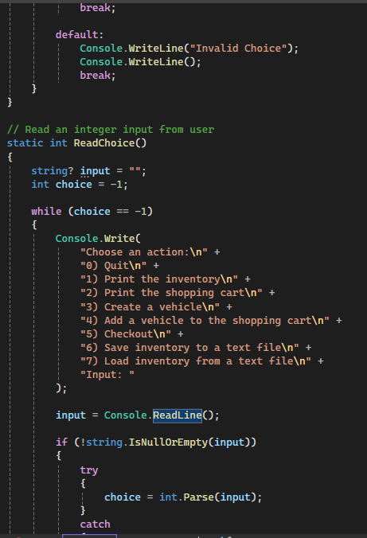

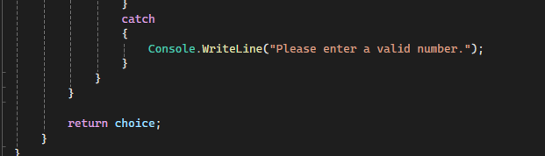

Part 3.

After completing the basic features, the project worked as below:

Adding vehicles and printing Inventory:

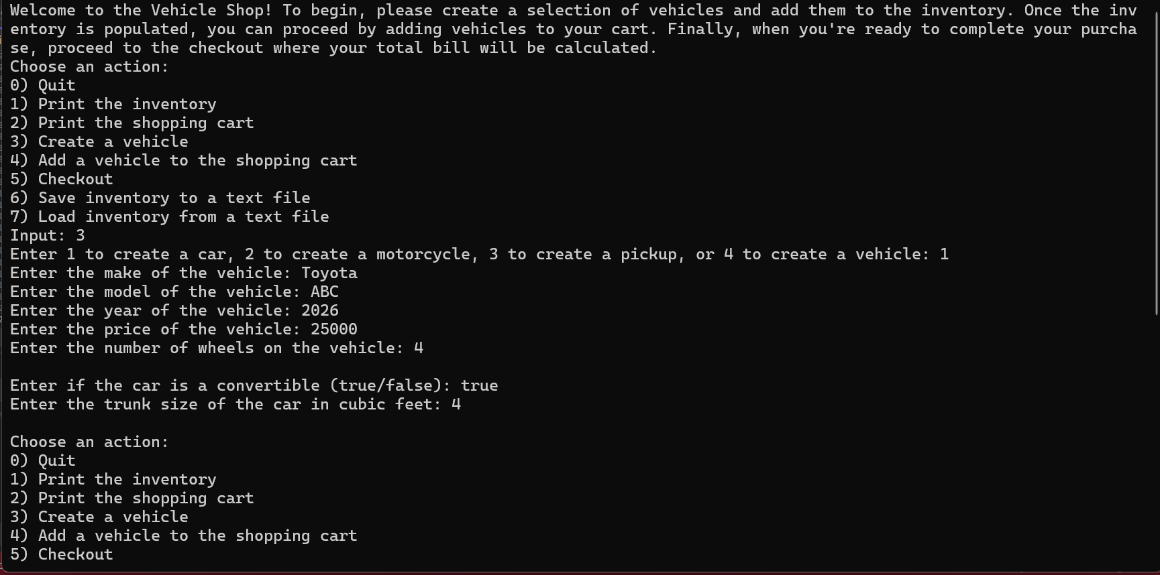

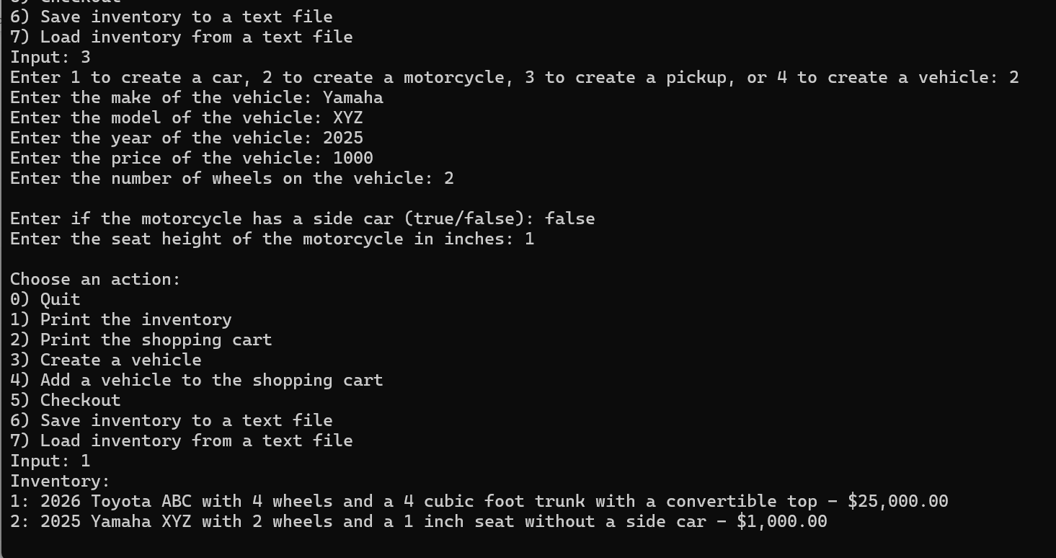

Adding to Cart

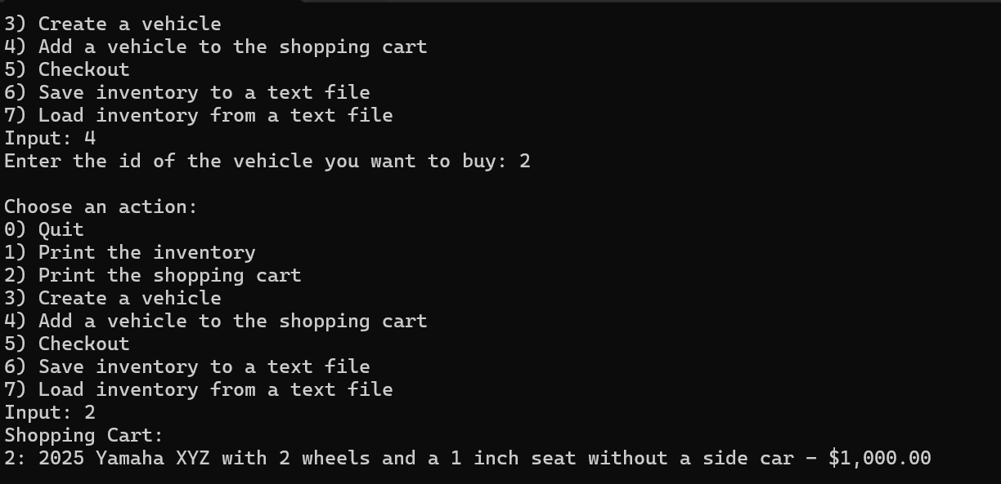

Checking out

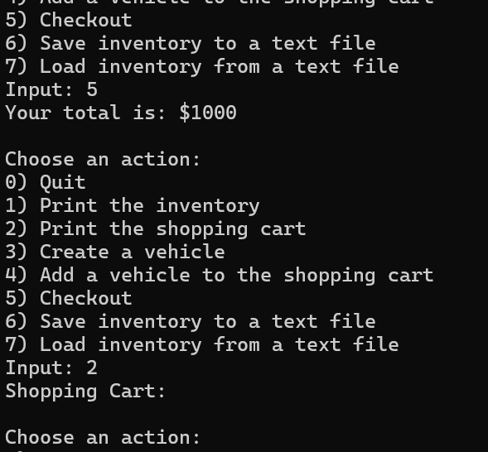

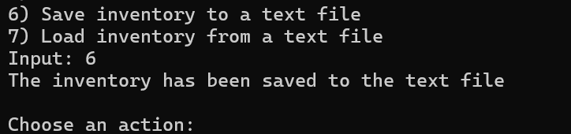

Note: Challenge is on next page.

Console App Challenge:

- Introduction of New Properties:

Color and Miles were added to the Car class. Below is where the code was updated

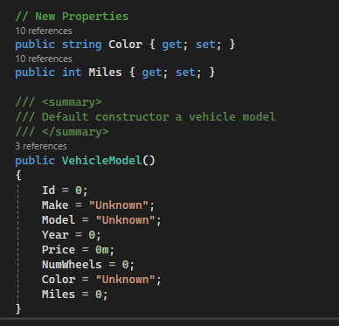

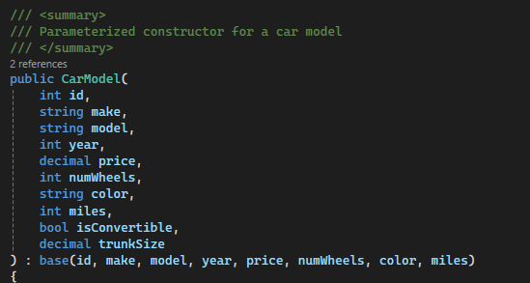

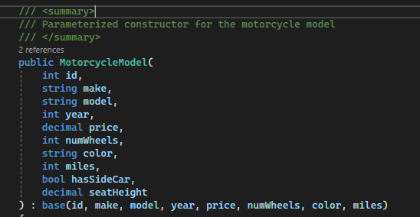

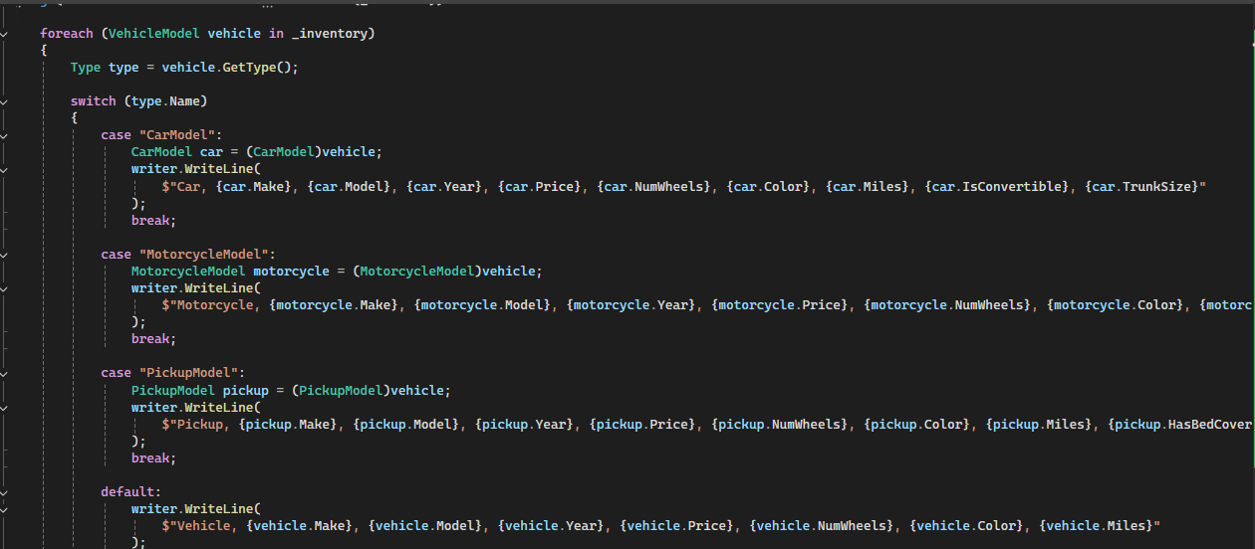

Below is how the program runs:

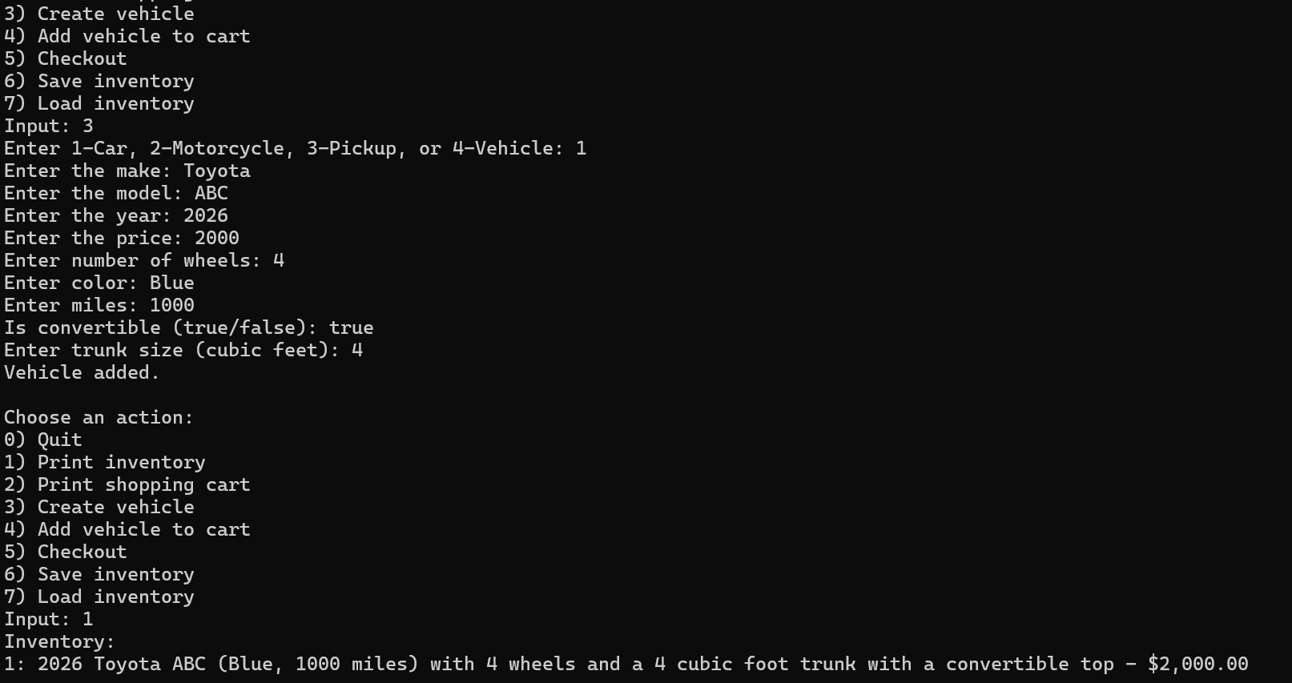
- Improved Error Handling:

To prevent application crashes from invalid user input, I've integrated TryParse for both decimal and integer conversions. This approach ensures that only valid numerical values are processed, significantly reducing the risk of runtime errors.

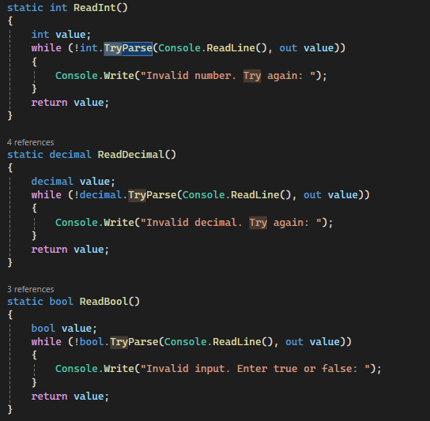

And the program now runs as follows:

